Programming Instruction

- Confirm your Windows operating system, and select the corresponding USB driver.
1.1, please download the usb driver from following link for your OS WINDOWS XP/WIN7/WIN8：

http://s000.tinyupload.com/?file_id=44167841291660960983

2.2 please download the usb driver from following link for your OS WINDOWS 10：

http://s000.tinyupload.com/index.php?file_id=04383576419424047631
- Install USB driver on the computer.
UPZIP the USB driver which you download to your compute, then choose file name “PL2303_Prolific_DriverInstaller_v1.9.0” (here take USB driver for Win7 as an explame), and double click it to install as belows,
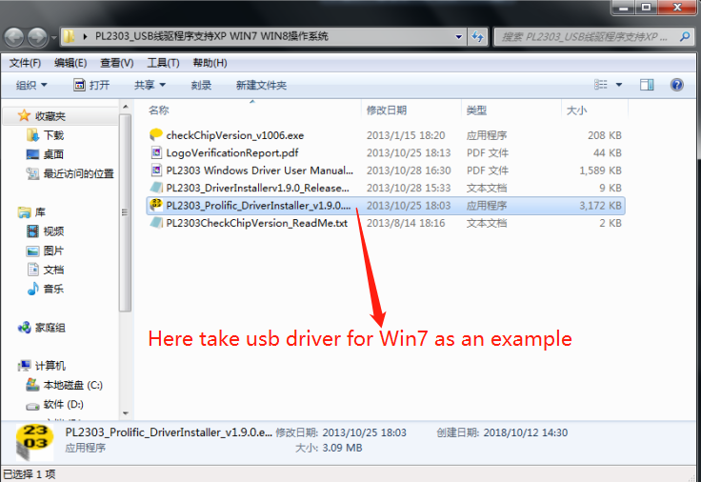

Click“Finsh”to complete the USB driver installed.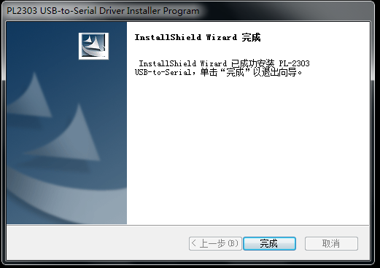

3.Recognize d USB programming cable by your PC
3.1) Plug program cable in the USB port on your computer.
3.2) Right-click “my computer” on your computer, choose “Device Manager” and double click to open it.
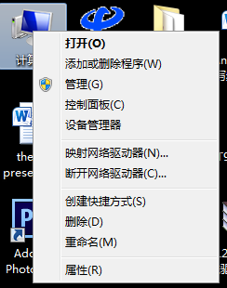

3.3) Find “Comm Port（COM&LPT）” and click, the computer recognized the program cable ( COM5) (As belows).
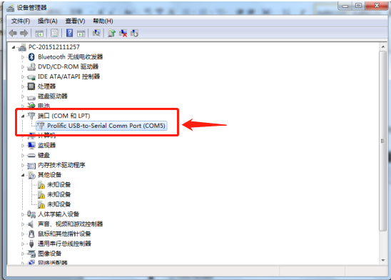
4.. Select and download the programming software you need.
4.1). For st-980plus mobile radio programming software, please download in this link
ST980PLUS_VIP_CPS.exe
http://s000.tinyupload.com/index.php?file_id=34249708966354942738

4.2).For ST-7900D mobile radio programming software, please download in this link:

http://s000.tinyupload.com/index.php?file_id=57909341972586926714

4.3). For Sc-600 portable radio programming software, please download in this link:

http://s000.tinyupload.com/index.php?file_id=09534597717183198903

4.4). For Sc-508 portable radio programming software, please download in this link:

http://s000.tinyupload.com/?file_id=43970121376580045916

4.5). For Sc-308 portable radio programming software, please download in this link:

http://s000.tinyupload.com/index.php?file_id=00343286838777269960

5. Here we take the ST-980Plus as an example for programming:
5.1)Download the ST-980PLUS software from the above link,
5.2)Then install it to your computer.
Double Click 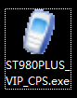 on your computer desktop to run the software.

In the software, click “communication” to select the corresponds communication port, then confirm as belows.

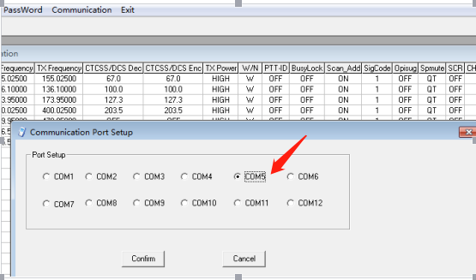

5.3) PLUG the USB programming to data port on the ST980PLUS, then power on the mobile radio.
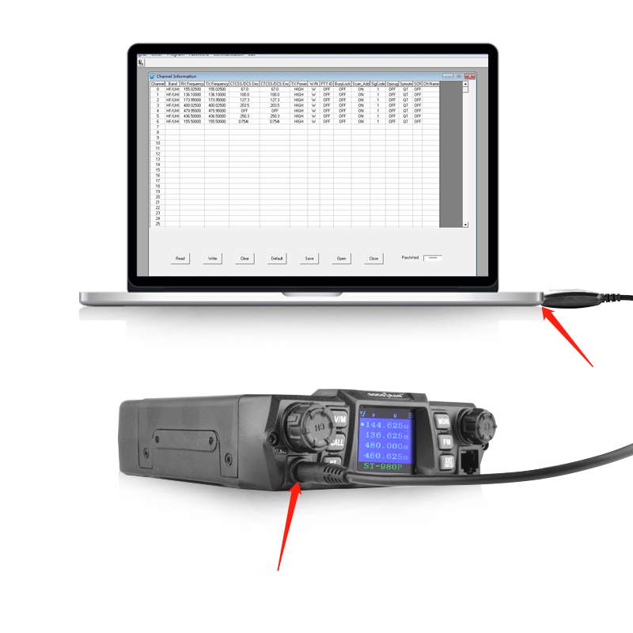
Click “” in the software to read the frequency from ST-980PLUS to your software on the computer.
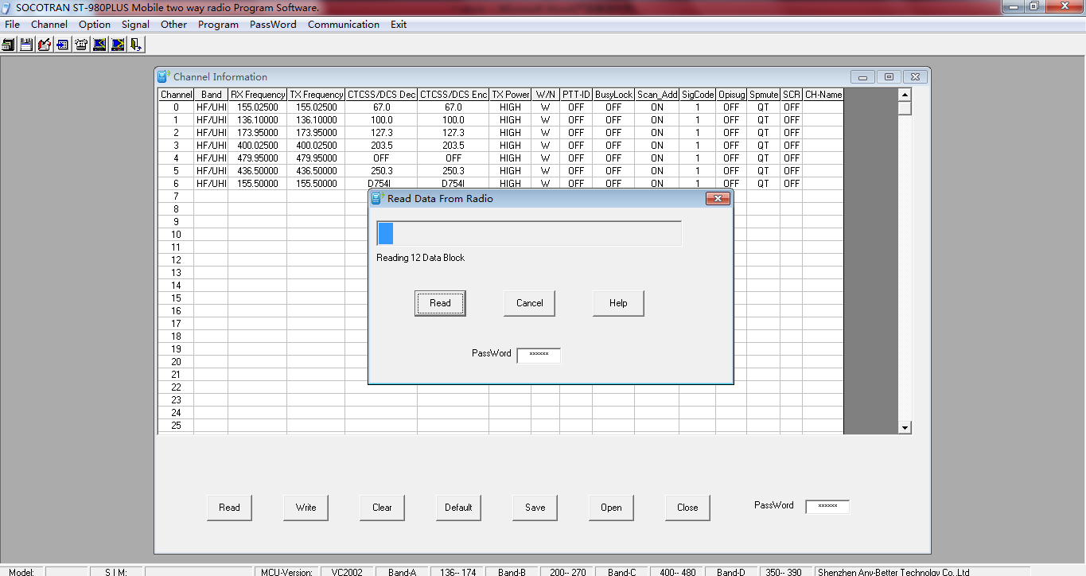

5.4) click “confirm” to finish reading the frequency, then you can change the frequency or settings on the software
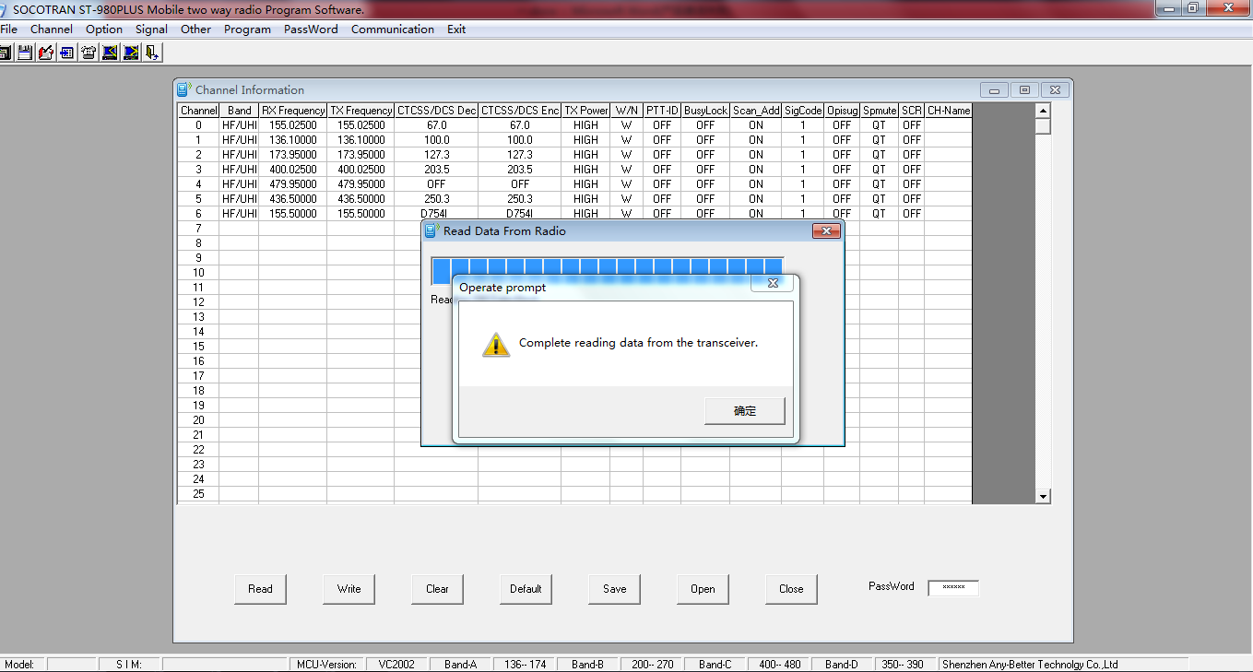

Change the frequency on the software as bellows:
(Note: the frequency you change to the software must be within frequency range of the radio, otherwise the radio will be burnt)
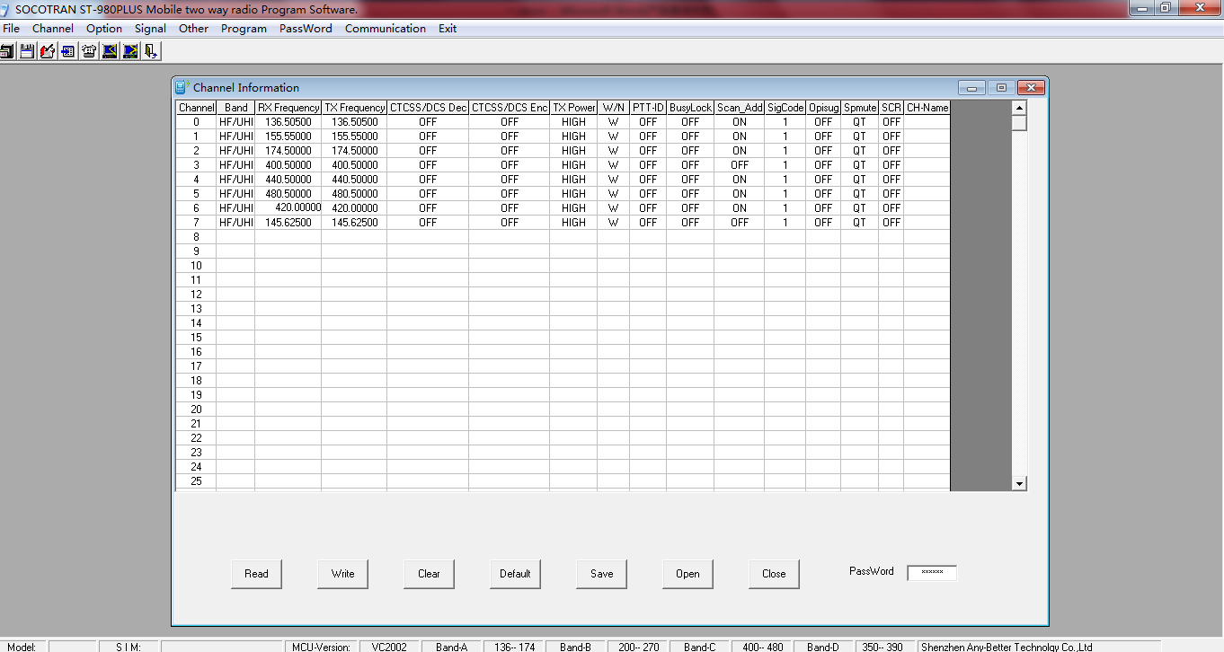
5.5) click “” to write the frequency & settings on the software to the ST-980PLUS
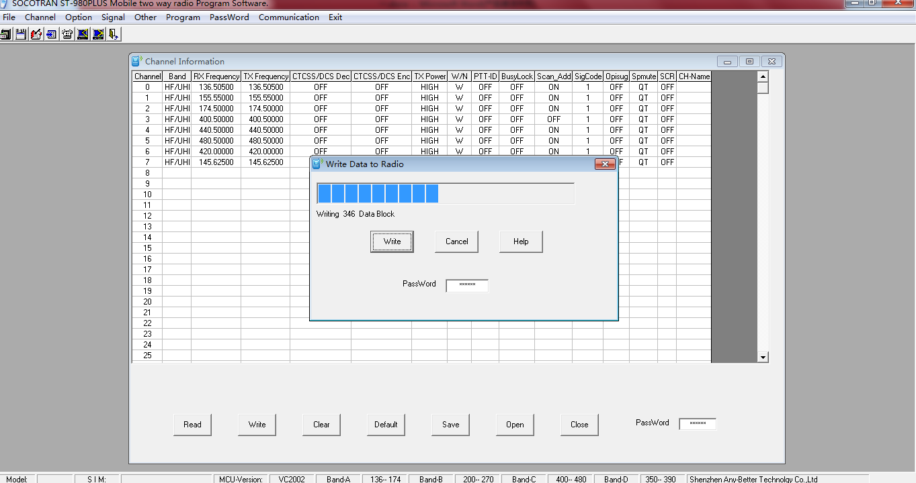

6.6) Click “ok” after the data wrote finished to confirm the programming complete:
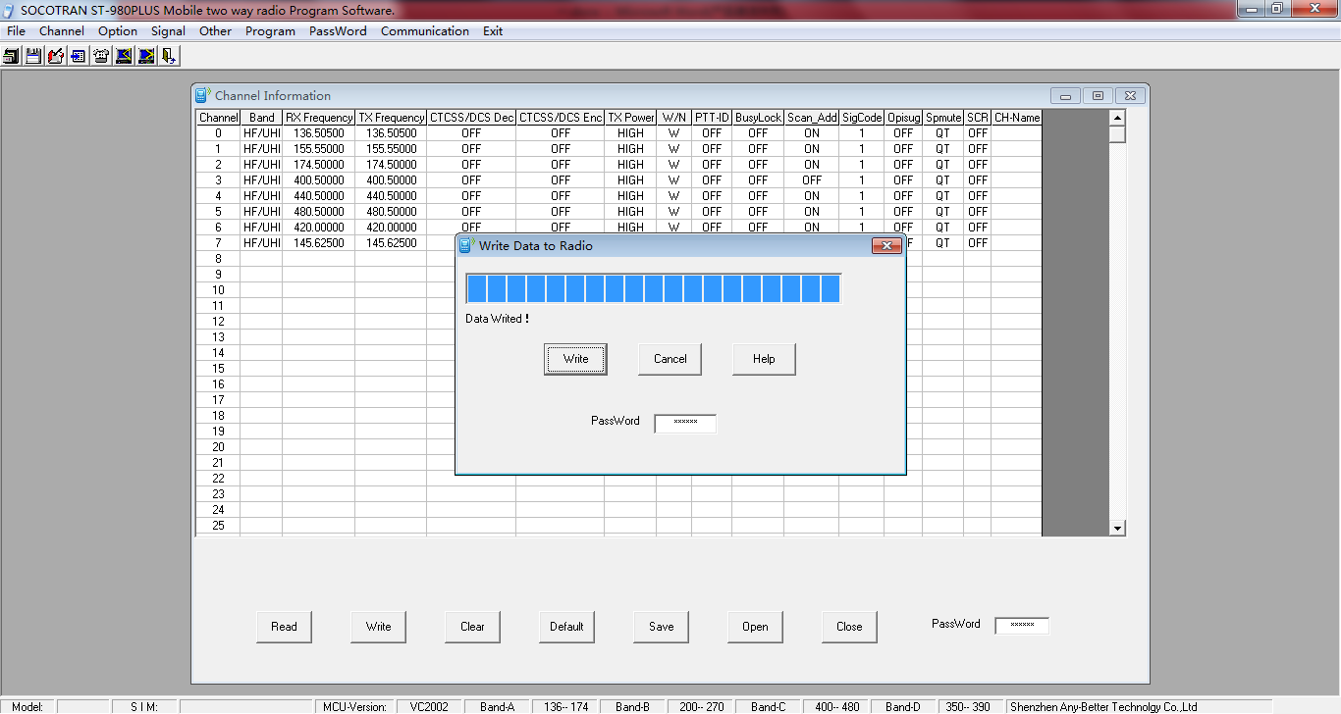
- Finished

